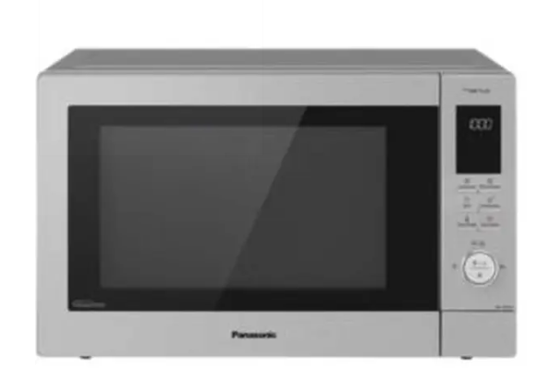
Panasonic convection microwave oven
Rs.58,000
Panasonic convection microwave NN-CT645MFSR combines microwave, convection, grill, and combination cooking with sensor support and a 27 litre capacity.

Specifications
- Model: NN-CT645MFSR
- Capacity: 27 Liters
- Microwave Power: 1000W
- Convection Power: 2500W

Key Features
- True convection
- 10 auto cook menus
- Sensor cooking
- Multi-stage cooking

